Class:5 Date: 08-06-2024
Agenda:
- Recap – Cluster and HDFS Cluster Administration.
- Known FACTS
- New -- HDFS Metadata Management
- New -- Hadoop 2.0 Architecture
Commonly Known FACTS:
Five Known Facts:
- Client is extremely important than internal team (TCS and FACEBOOK example).
- Every laptop/mobile would have RAM and Hard Disk.
- RAM is Faster than Hard Disk. Any Application gets stored on HDD and runs on Ram.
- If save large files from RAM to HDD, a chance machine gets hung for a moment.
- If you do not save the file. If a machine get restarted Data on RAM would be lost.
If client asks anything, name node immediately asks FSIMAGE, FSIMAGE maintain all the information related to Data nodes, where data is stored on what node, transaction information etc. FSIMAGE is heart of Hadoop. FSIMAGE plays a crucial role in entire Hadoop environment.
To serve client, FSIMAGE to be maintained/managed in RAM for faster Retrieval. FSIMAGE has lots of data and data increases exponentially,. If we commit FSIMAGE to HDD, there is a chance that node gets hanged and serving client gets delayed.
Now Lets say FSIMAGE got entirely filled up, we need to save/checkpoint the FSIMAGE to some location. If we don’t save the data, data will be lost if machine gets restarted.
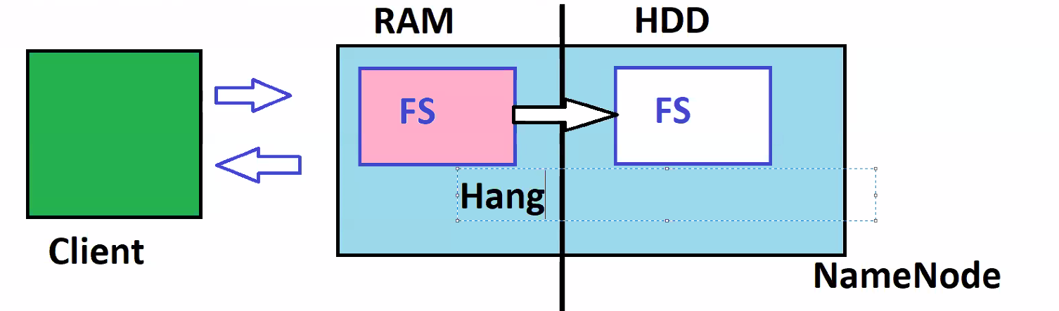
How Doug Cutting managed to save FSIMAGE, without data loss?
That’s the moment he bought Hadoop Metadata management.

Hadoop Metadata Management:
we have a client, name node, secondary name node and data nodes.,
To serve client, by the time cluster gets started, it immediately puts FSIMAGE copy on RAM. Along with FSIMAGE it also places another file on RAM called EDITLOG(lighter in nature, easily commit to HDD, size will be very small).
As the work getting started, some transaction has happened, say some data come into data nodes got divided and stored.
Any data transaction happens say data change, data movement, data deletion etc, that transaction data gets stored in FSIMAGE in RAM, EDITLOG in RAM and also EDITLOG in HDD in Name Node.
As client dependant on FSIMAGE, EDITLOG has no dependency, so any transaction happens, it gets logged inside FSIMAGE in RAM, EDITLOG in RAM and also EDITLOG in HDD in Name Node. After some time if transaction happens, those record will also be stored in FSIMAGE in RAM, EDITLOG in RAM and also EDITLOG in HDD in Name Node .
After one hour, whatever the transactions happens they also be available in FSIMAGE in RAM, EDITLOG in RAM and also EDITLOG in HDD, then secondary name node takes FSIMAGE from HDD of Name Node, recent EDITLOGS on HDD from Name Node and merges EDITLOG file to FSIMAGE in secondary Name node. Then That updated FSIMAGE from secondary Name node gets committed/saved to HDD in name node. EDITLOGS in HDD name node get refreshed.
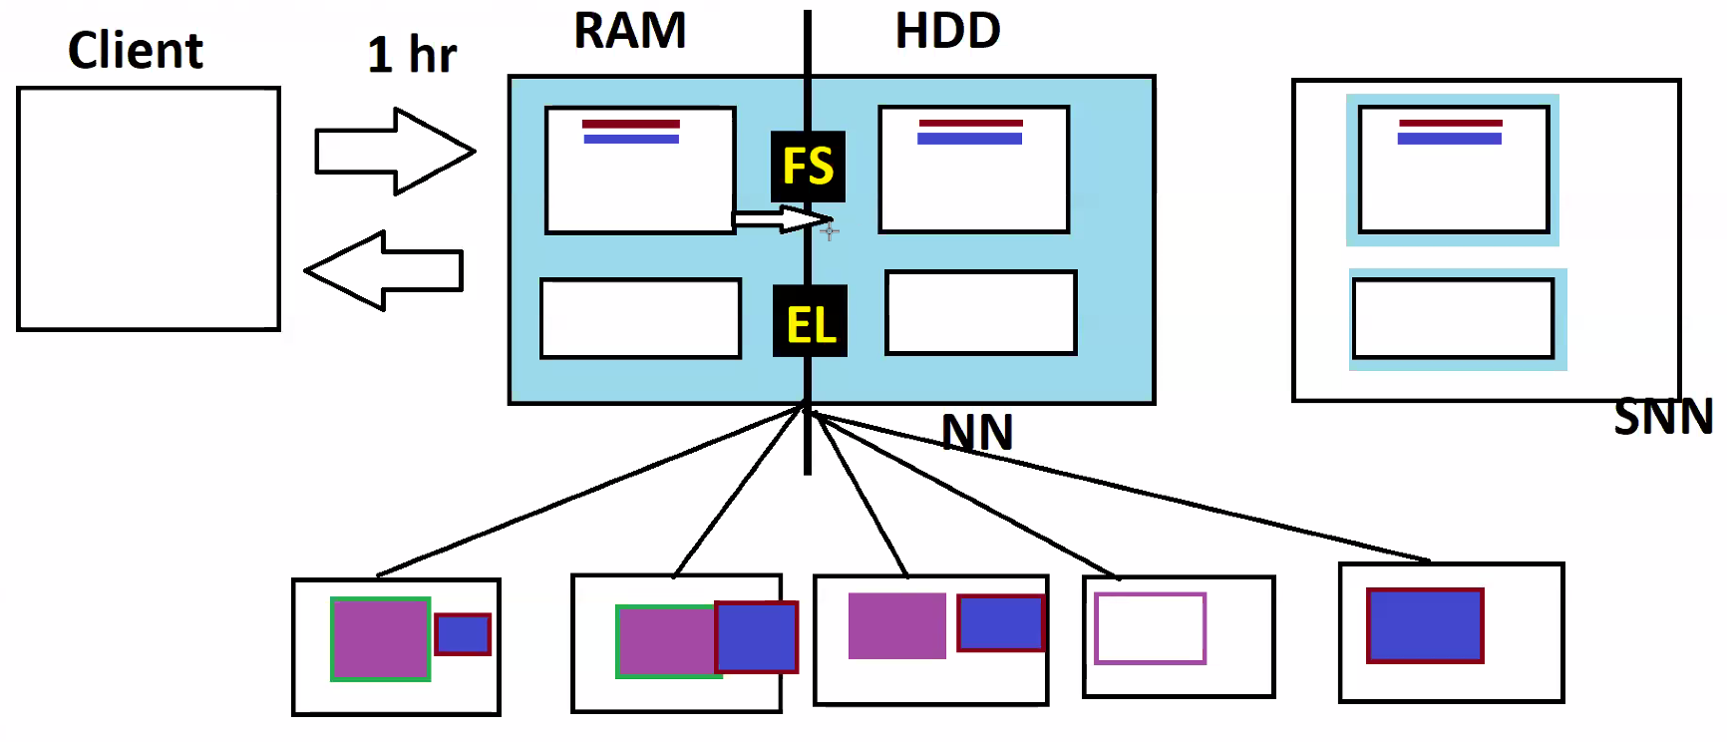
Again after some let say some transactions has happened, after one hour, Secondary name node merges EDITLOG from name node HDD to FSIMAGE in name node HDD and EDITLOGS from name node HDD get refreshed. Sends back FSIMAGE to name node HDD.
Both FSIMAGE in RAM and FSIMAGE in HDD of Name Node will be in sync for every one hour.
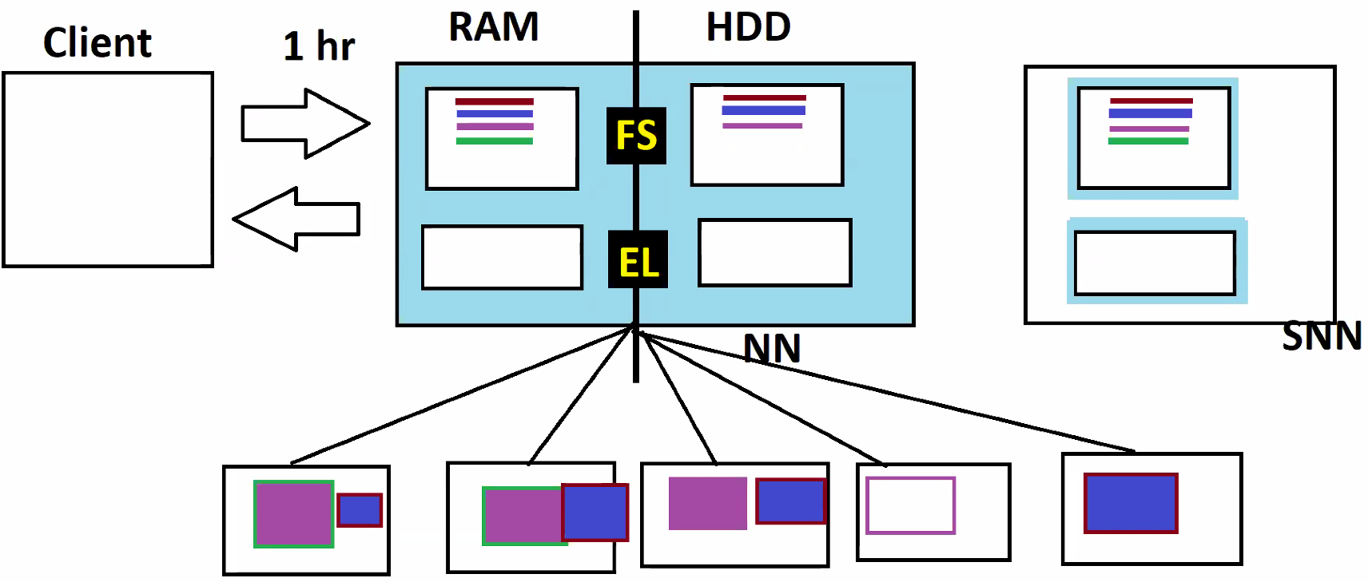
After some time, some transactions happened and gets logged in FSIMAGE in RAM, EDITLOG in RAM and also EDITLOG in HDD of a Name Node , after 30mins suddenly Name node got restarted, data(FSIMAGE,EDITLOG) on RAM in Name node is lost.
Once Name node gets restarted, it immediately goes into SAFEMODE, that time informs client, data nodes to wait, until name node is ready with FSIMAGE on RAM. Now Name node brings FSIMAGE, EDITLOGS from HDD to RAM and does its own checkpointing/merge and starts serving the client.
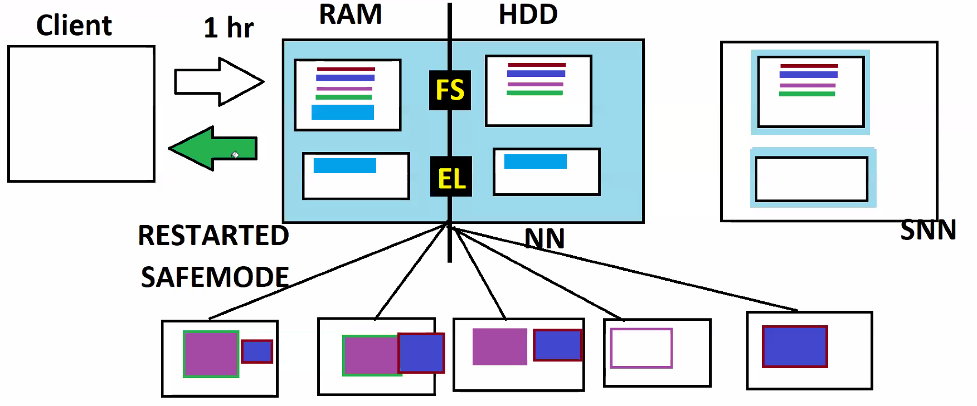

If the name node entirely gets dead or lost, all the data in HDD is lost. We cannot make secondary name node to work as Name node as it has older FSIMAGE, it does not have recent transactions which are not merged with FSIMAGE. That’s the main drawback of Hadoop 1.0 Architecture, called Name Node Failure.

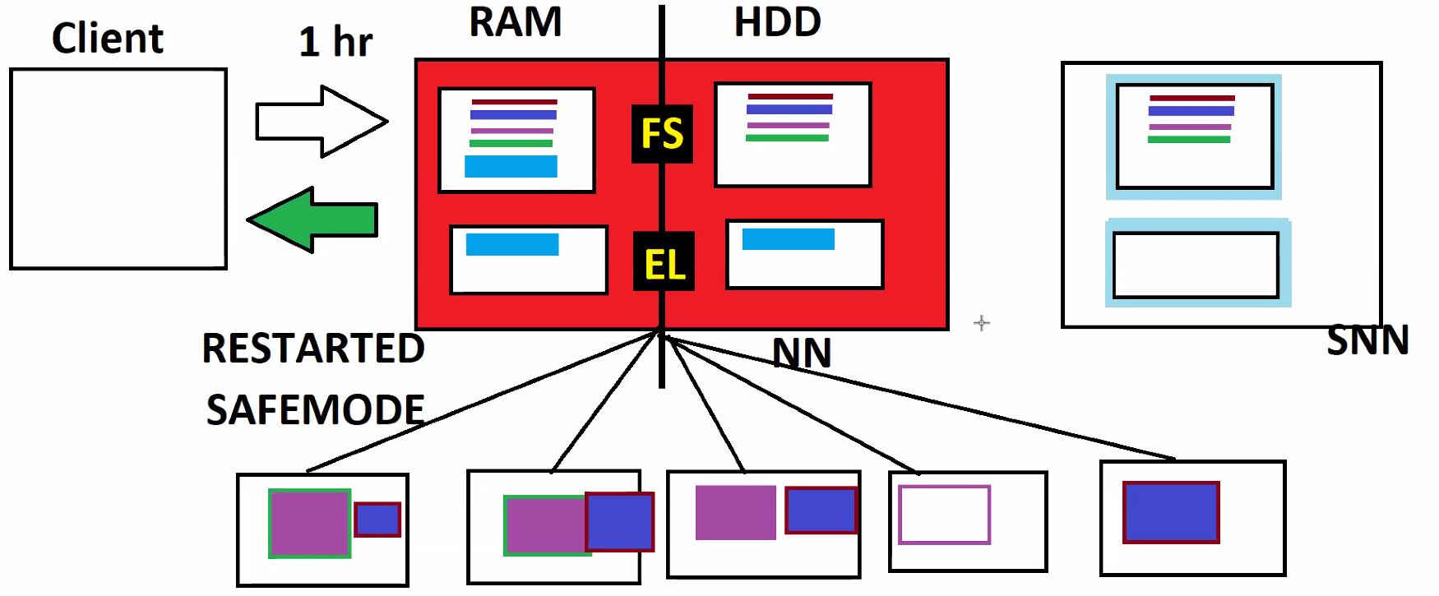

Instead of storing EDITLOGS in Name node, if we store it somewhere, we can send that EDITLOGS to secondary name node and it recreates FSIMAGE and acts as Name Node. That how Hadoop 2.0 works.

Hadoop 2.0 Architecture:
ZOOKEEPER is appointed in Hadoop2.0 to handle all failures. Will have control on all these nodes. Takes care of cluster failures, delays, etc.
Name Node Instructions/Changes:
- Name changed from Name Node to Active Name Node.
- You will have a file in_use.lock, that indicates it’s Active Name Node.
- Keeps writing EDITLOGS to Journal Nodes.
- ZOOKEEPER keeps watching the health of Active Name node.
Secondary Name Node Instructions/Changes::
- Name changed to StandBy Name Node.
- Does not have in_use.lock file. Only Active node has it.
- Reads EDITLOGS from Journal Nodes for merging.
- Follows instructions from ZOOKEEPER.
Date Node Instructions/Changes:
- Before connected only with Name Node in Hadoop1.0, In Hadoop 2.0 Data node gets connected to both Active and stand by Name node.
- Send Transactions information only to the node having in_use.lock file.

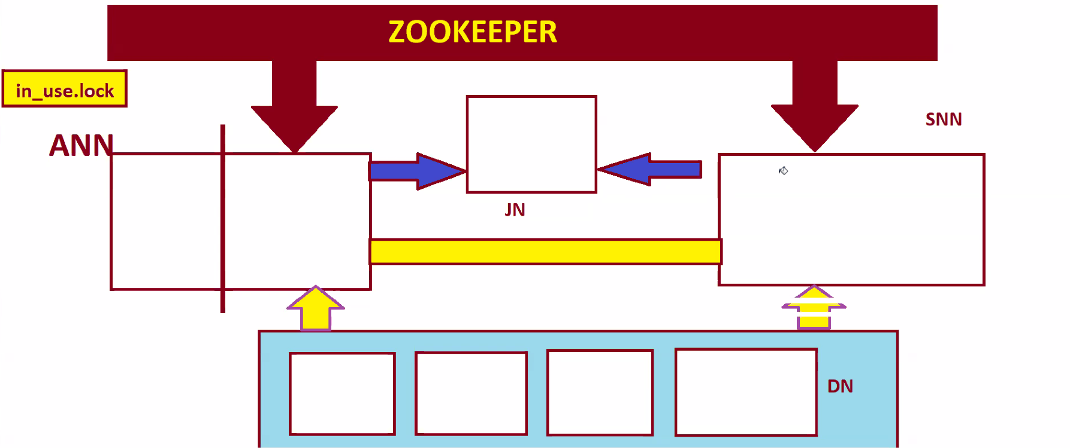
Zookeeper monitors all nodes. Active NN will write EDITLOGS to Journal Nodes. Standby NN takes EDITSLOGS from Journal Nodes. Active NN and Standby Node are connected which shares FSIMAGE.
All the data node are internally connected to each other. Data nodes are strongly connected to Active NN but partially connected to Standby NN.
Active NN and Standby NN are coupled to each other and shares FSIAMGE.

When work gets started, immediately FSIMAGE in HDD comes to RAM in Active Name node. If any, Transactions gets recorded in FSIMAGE IN RAM in Active NN then also in EDITLOGS Journal Node.
After one hour, FSIMAGE FROM Active Name Node will be sent to Standby Name Node, and EDITLOGS from Journal Nodes also sent to Standby name node. Standby NN merges EDITLOGS to FSIMAGE and sends FSIMAGE back to HDD of Active NN.
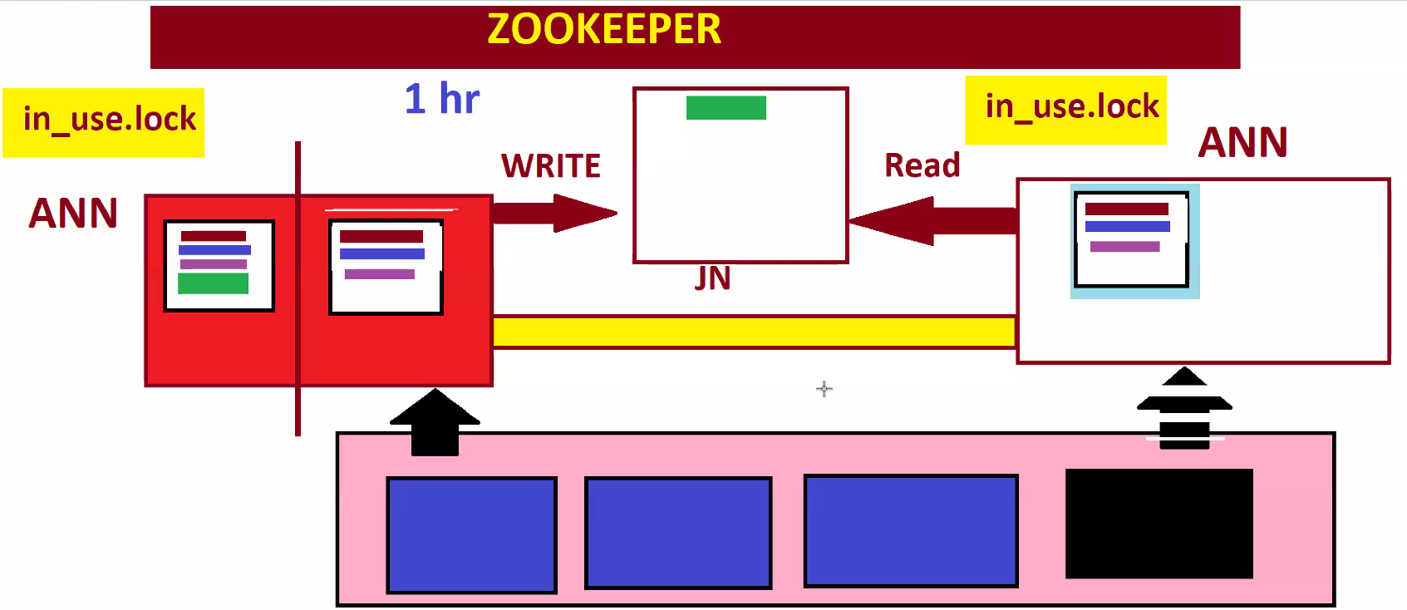
Say some transaction has happened and saved in FSIMAGE in RAM of Active NN, also saved in EIDTLOGS in Journal nodes. Now active Name node stopped responding. Zookeeper is closely watching the health of ANN. As soon as Zookeeper confirms ANN is dead and asks Standby NN to go Safe mode and to create it’s own in_use.lock file, then standby NN reads EDITLOGS from Journal nodes and merge it with FSIMAGE become Active Name node and starts serving client. Now Data node are closely coupled with new Active Name node and partially coupled with dead node. At that particular moment as we don’t have any standby NN, new Active NN also does the work of Standby NN, it goes safe mode every one hour and does checkpointing.
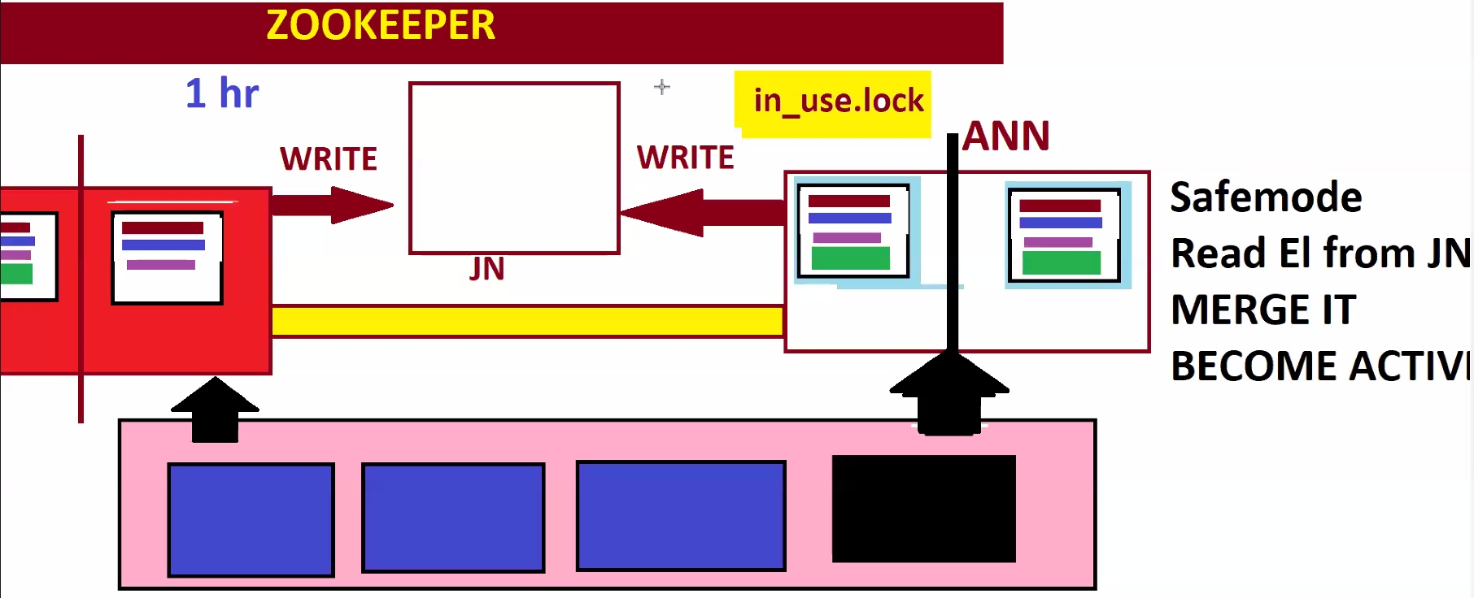
Before we replace dead node, Now major risk is, after some time dead active name node starts responding, now both node are having in_use.lock file, both acts as Active name node And transactions gets duplicated and recorded into EDITLOGS of Journal Node from both Active name nodes. This Scenario is called SPLIT BRAIN SCENARIO.
To stop the write, Zookeeper sends some fencing program to stop the write, then instructs dead Active name node to remove in_use.lock file . so that it acts standby NN. Then Fencing is removed.
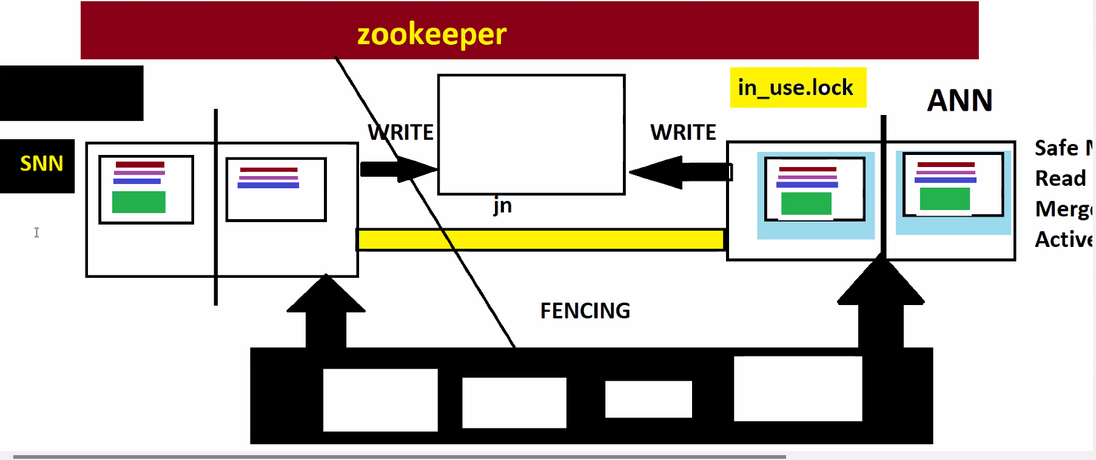

Original Architecture by released by Hadoop 2.0:
